**Ideation Phase**

**Brainstorm & Idea Prioritization Template**

Date

2025

April

18

Team ID

SWTID1743603827

Project Name

Book Store

-

Maximum Marks

4

Marks

**Step-1: Team Gathering, Collaboration and Select the Problem Statement**

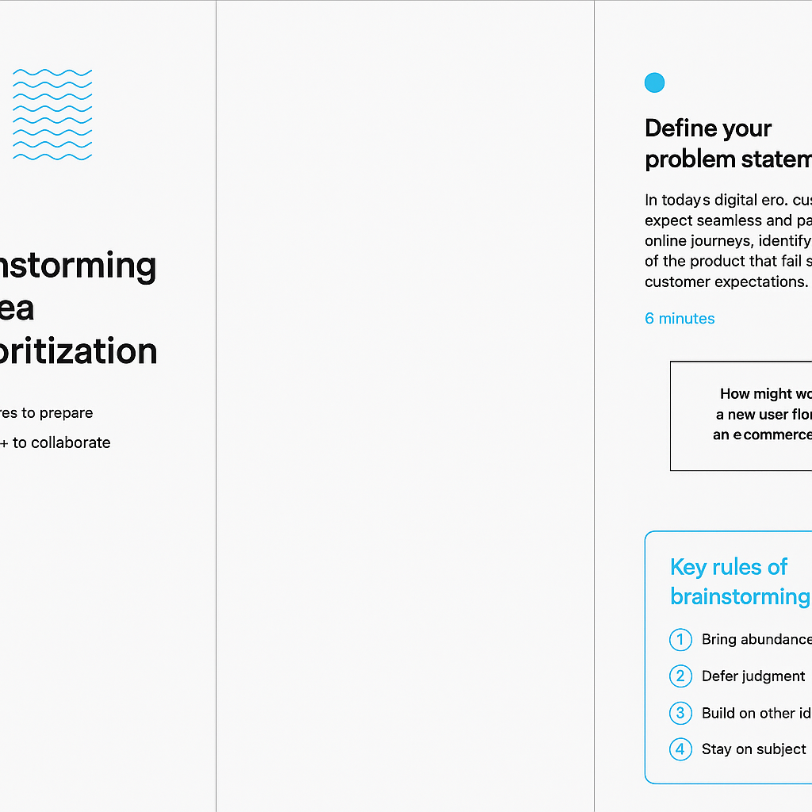

**Step-2: Brainstorm, Idea Listing and Grouping**

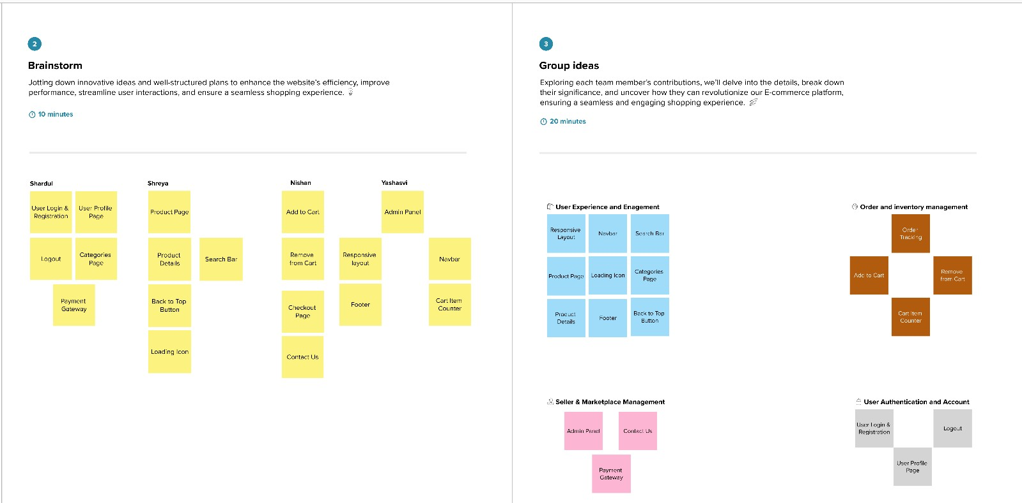

**Step-3: Idea Prioritization**

